TEAM BIOS WRITEUP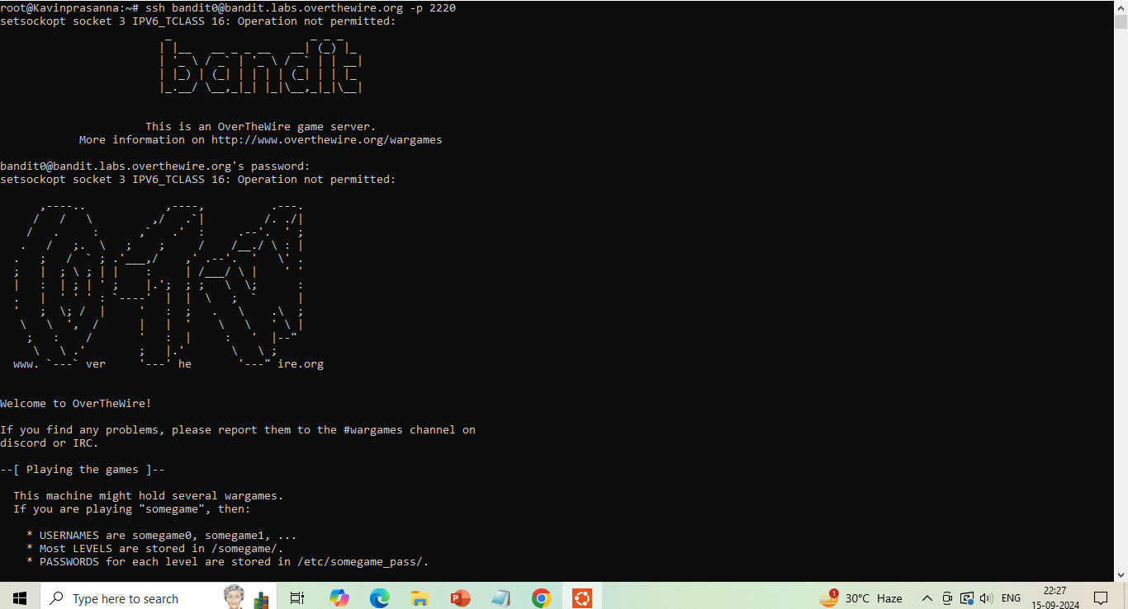

The host to which you need to connect is **bandit.labs.overthewire.org**, on port **2220**. The username is **bandit0** and the password is **bandit0**. The password for the next level is stored in a file called **readme** located in the home directory.

$ ssh bandit0@bandit.labs.overthewire.org -p 2220

Command cat is used to read the file

 The cat command reads each File parameter in sequence and writes it to standard output. If you do not specify a file name, the cat command reads from standard input. You can also specify a file name of - (dash) for standard input

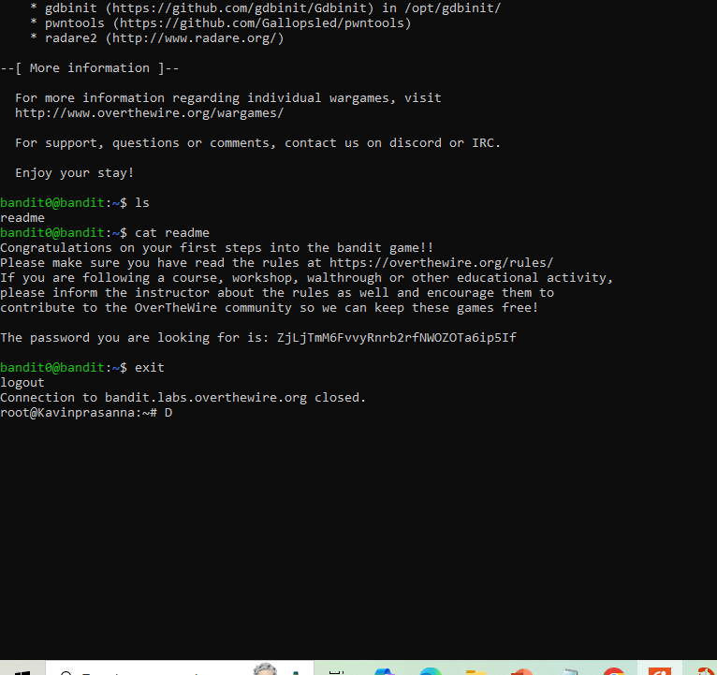

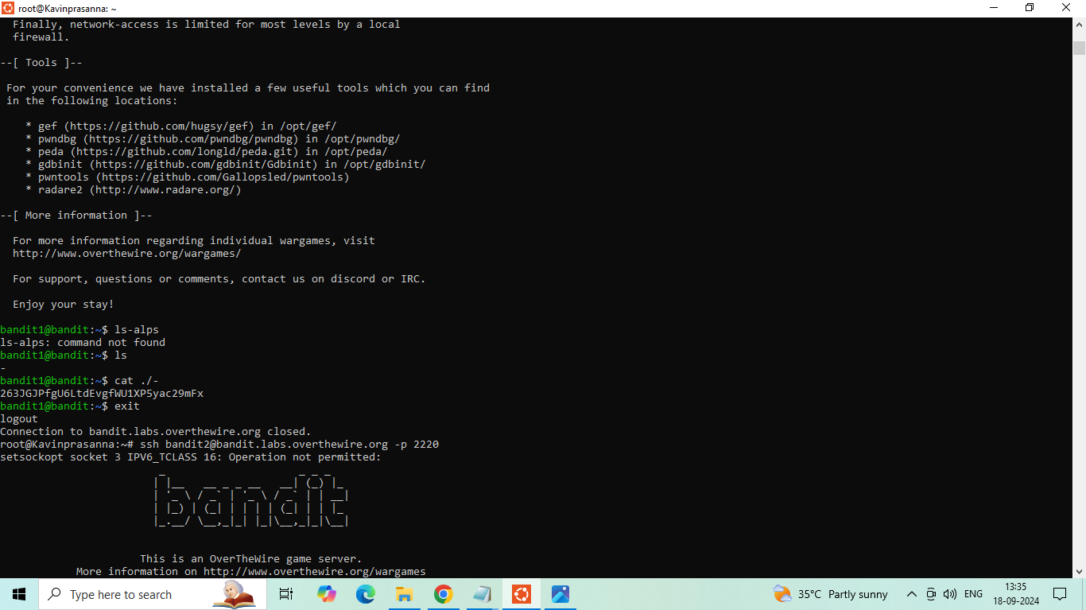

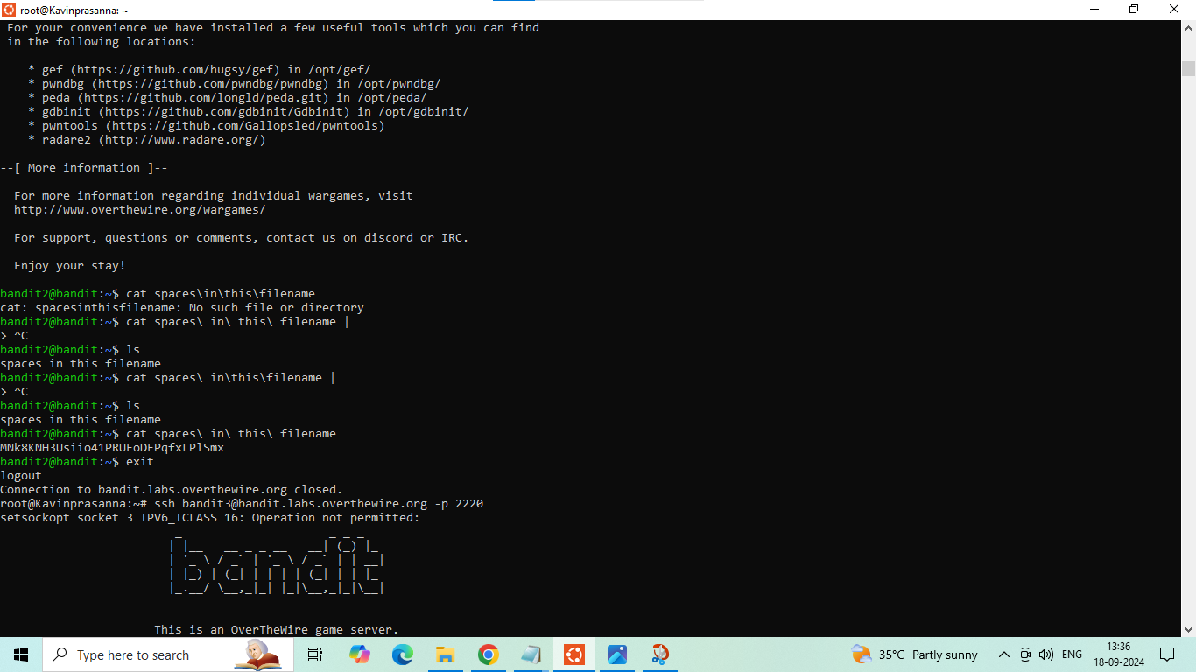

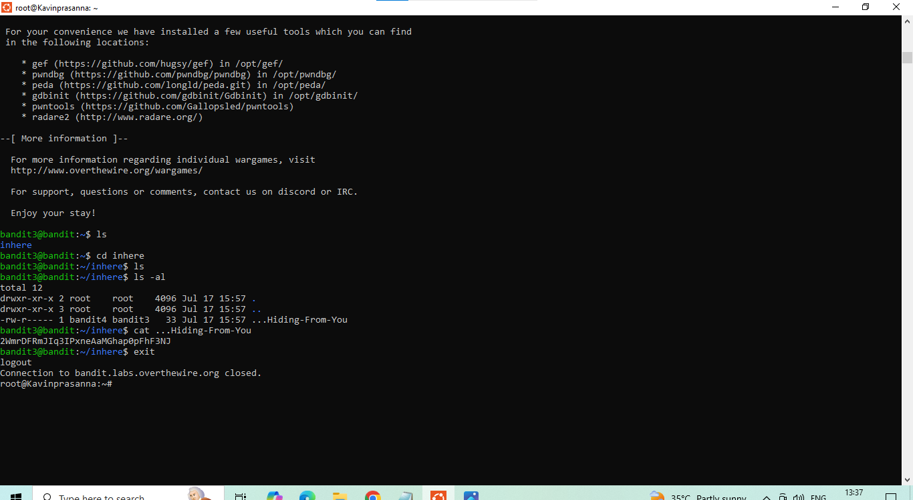

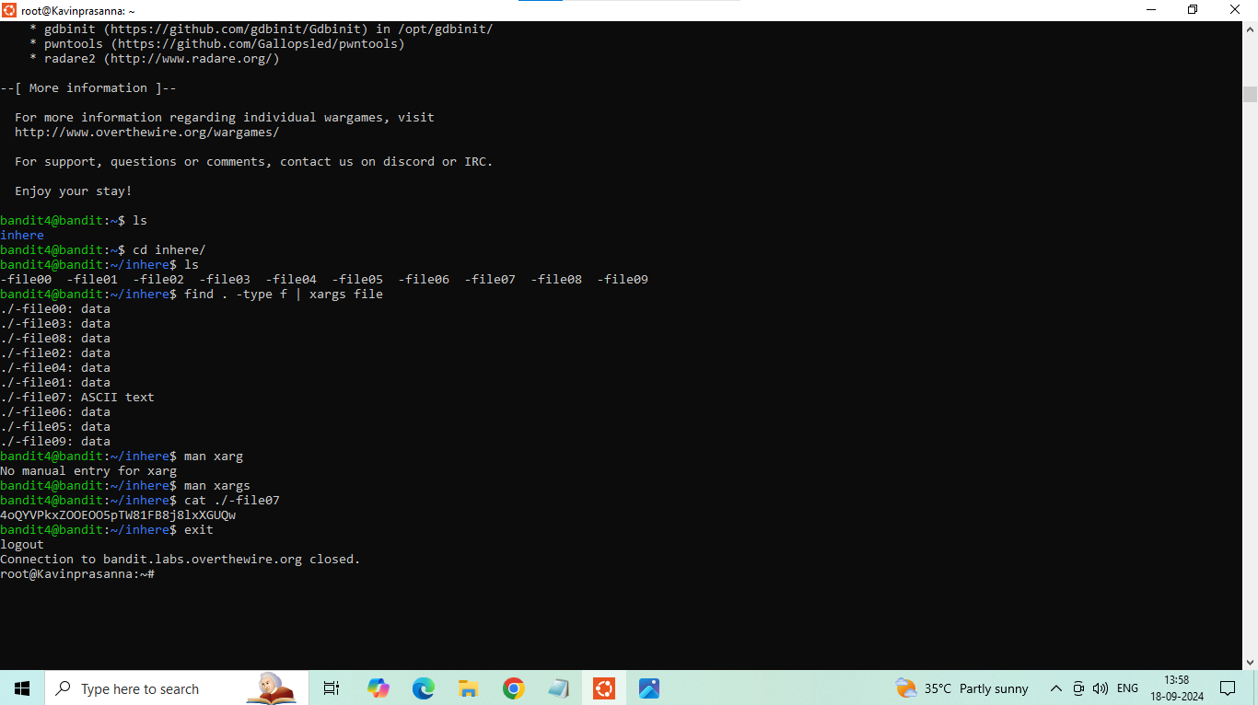

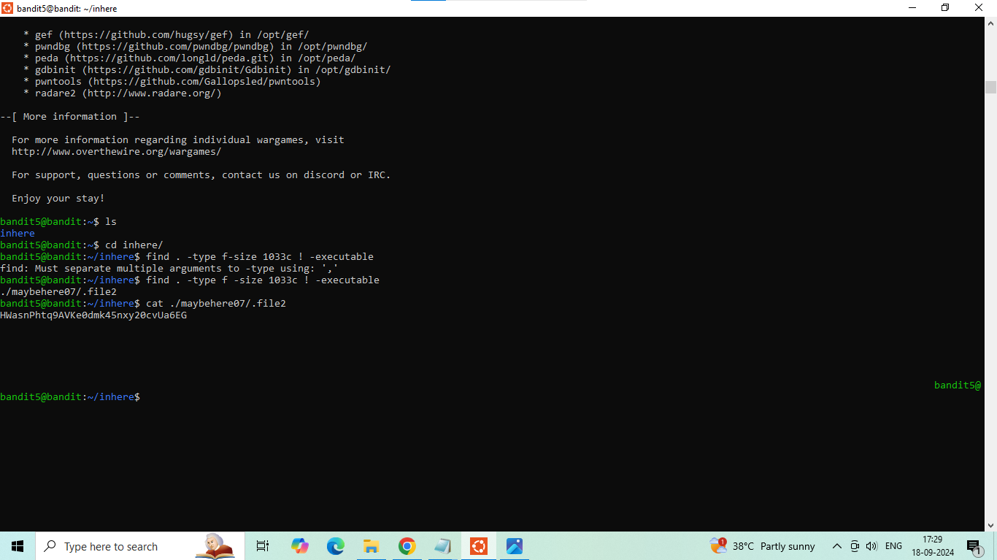

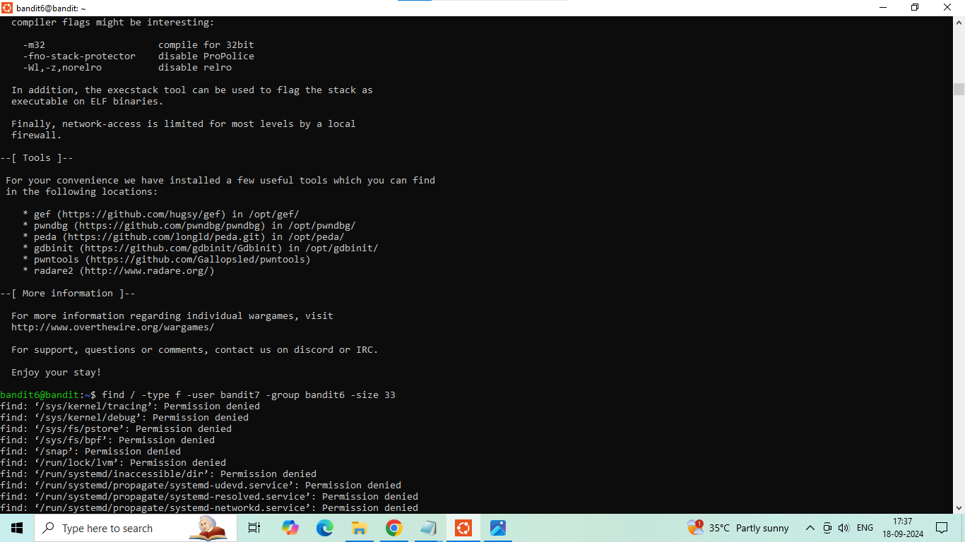



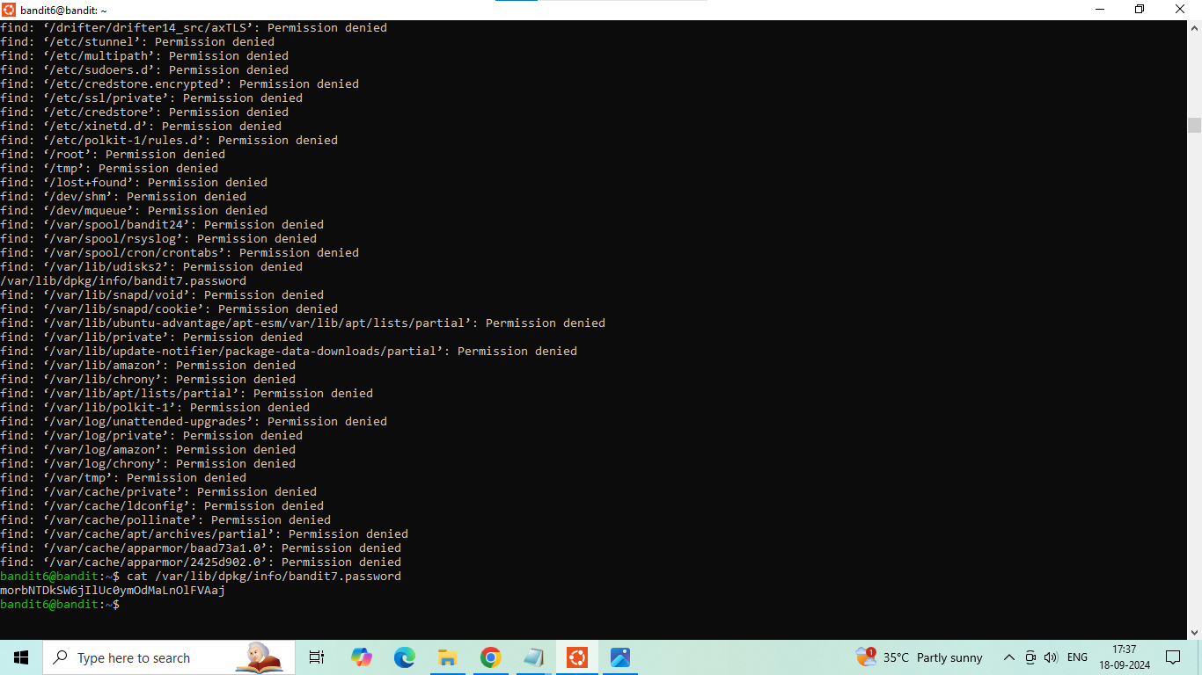

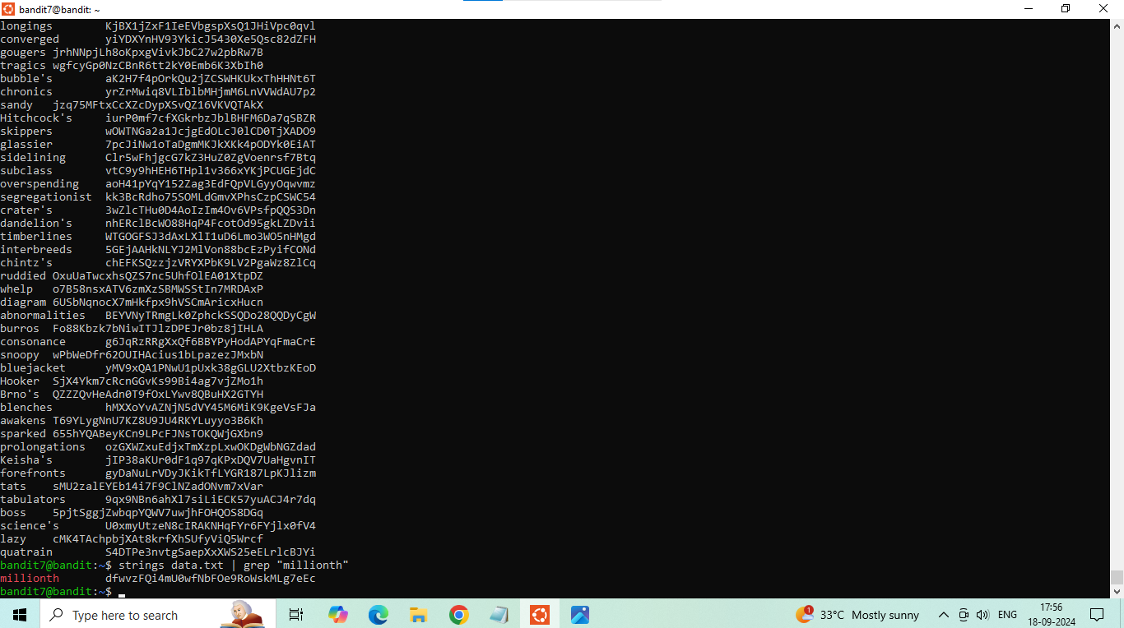

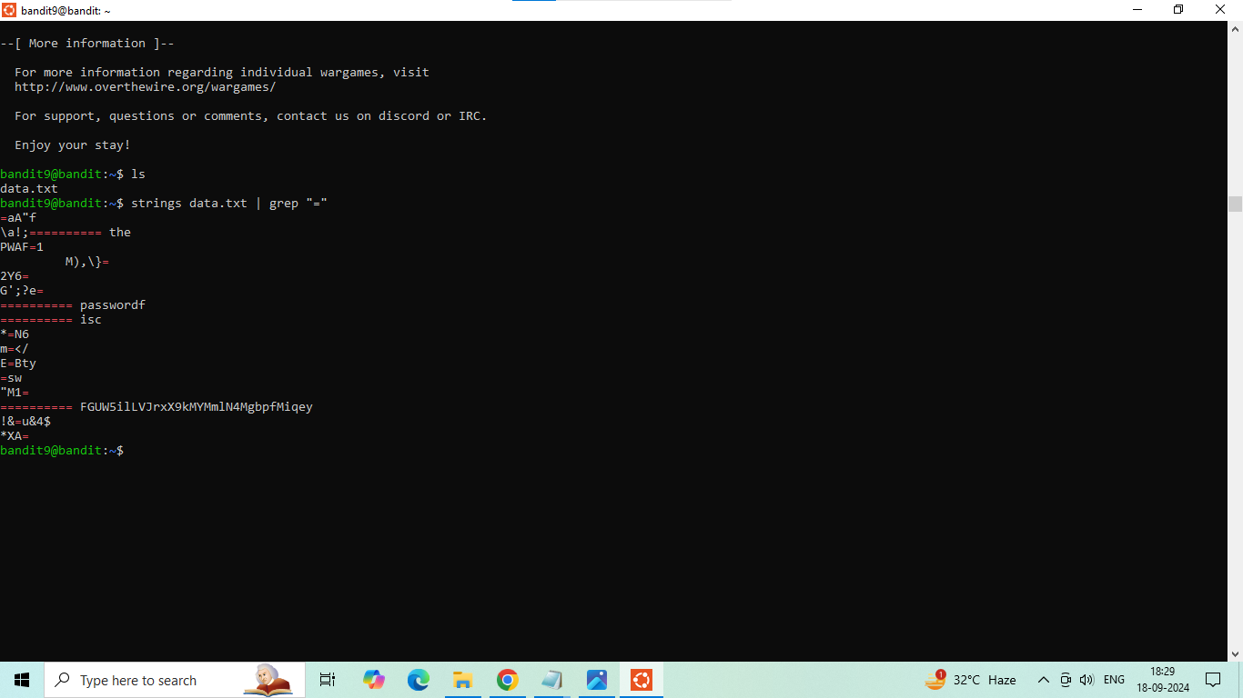

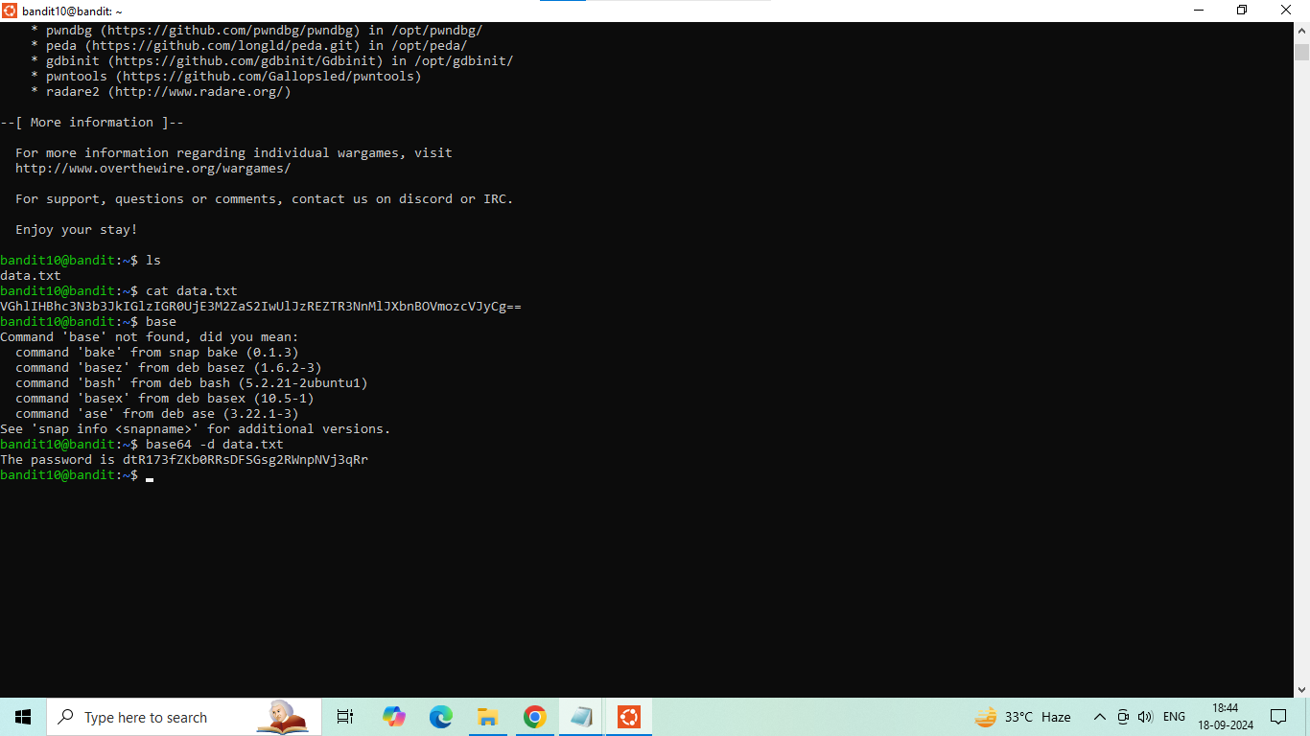

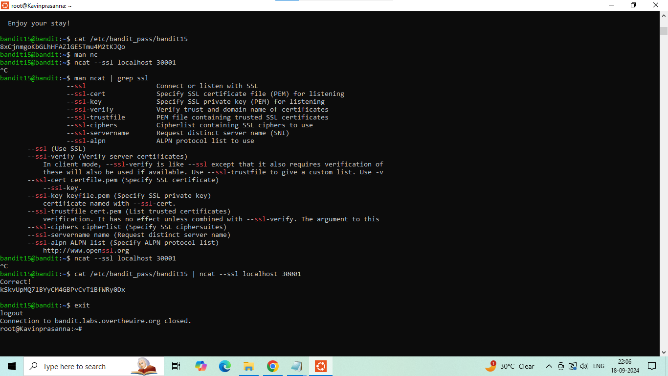

Overall Commands I learnt is :

to check all the files inside it is command:file ./-file*

to read the file command:cat ./-file(number)

description:human readable,1033 bytes in size,not executable

answer:find . -size 1033c \! -executable or find /(given properties)

COMMANDS:

grep:It is an primary search tool used to find the specific strings or

specific configuration file.

sort:identical lines of text or identical passwords into groups

uniq:remove all the duplicates which are similar

pipeline operator:output of one process and set into the other process

command u(unique):Which print only unique lines

strings:strings prints the printable character sequences that are

atleast 4 characters,and strings are mainly useful forn determining the contents of non text files and also show the human readable contents

base64:If we didnt know that the string is base 64 we can find it by seeing the equal signs of of the string

translate (tr):Used to translate the first set of characters and after by using tr with a-zA-Z n-za-mN-ZA-M

xxd:creates a hex dump of a given file or standard output

what is hexdump?

Hexdump is used to examine the contents of files, particularly binary files or unknown file formats.

It helps programmers and analysts understand the structure and data stored in the file.

Debugging. Programmers use Hexdump to investigate issues in their code.

xxd -r:xxd -r [hexadecimal dump file path] Converting hexadecimal dump to the original file.

The hexadecimal dump was saved in a file called “hexdump. txt,” and we used the '-r' option to reverse this process,

converting the hex dump back into its original format.

gzip,gunzip,zcat -compress or expand files

gzip(with an letter d means)-helps to decompress

netcat(nc):This command is used to in variety of network related tasks.Reading and writing data: The nc command can read and write data between two computer networks.

Creating sockets: The nc command can create TCP and UDP sockets for network communication.

Port scanning: The nc command can scan ports.

File transfer: The nc command can transfer files.

Port listening: The nc command can listen on arbitrary TCP and UDP ports.

Network debugging: The nc command can be used for network debugging and investigation



COMPLETED JAVA;

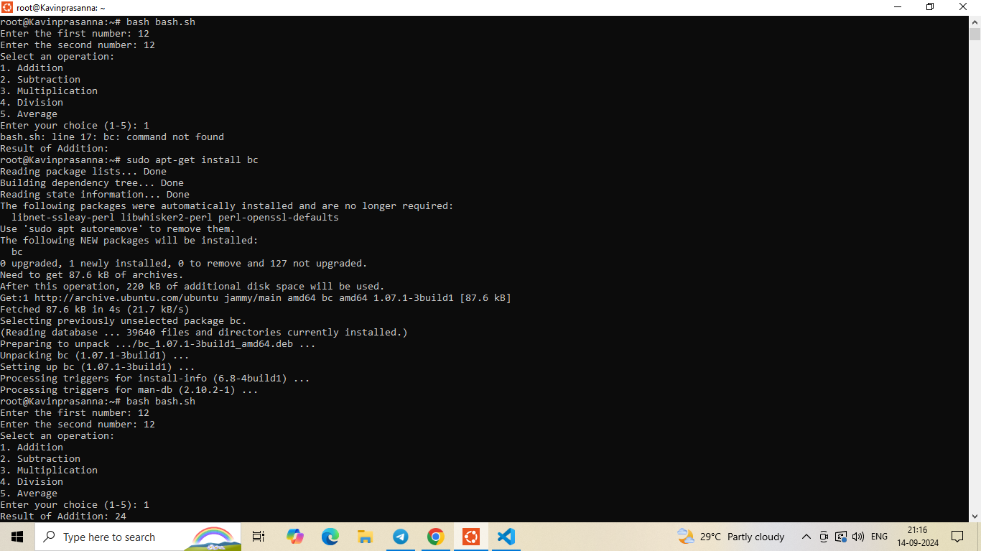

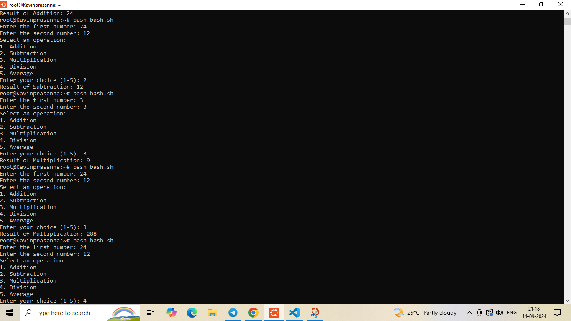

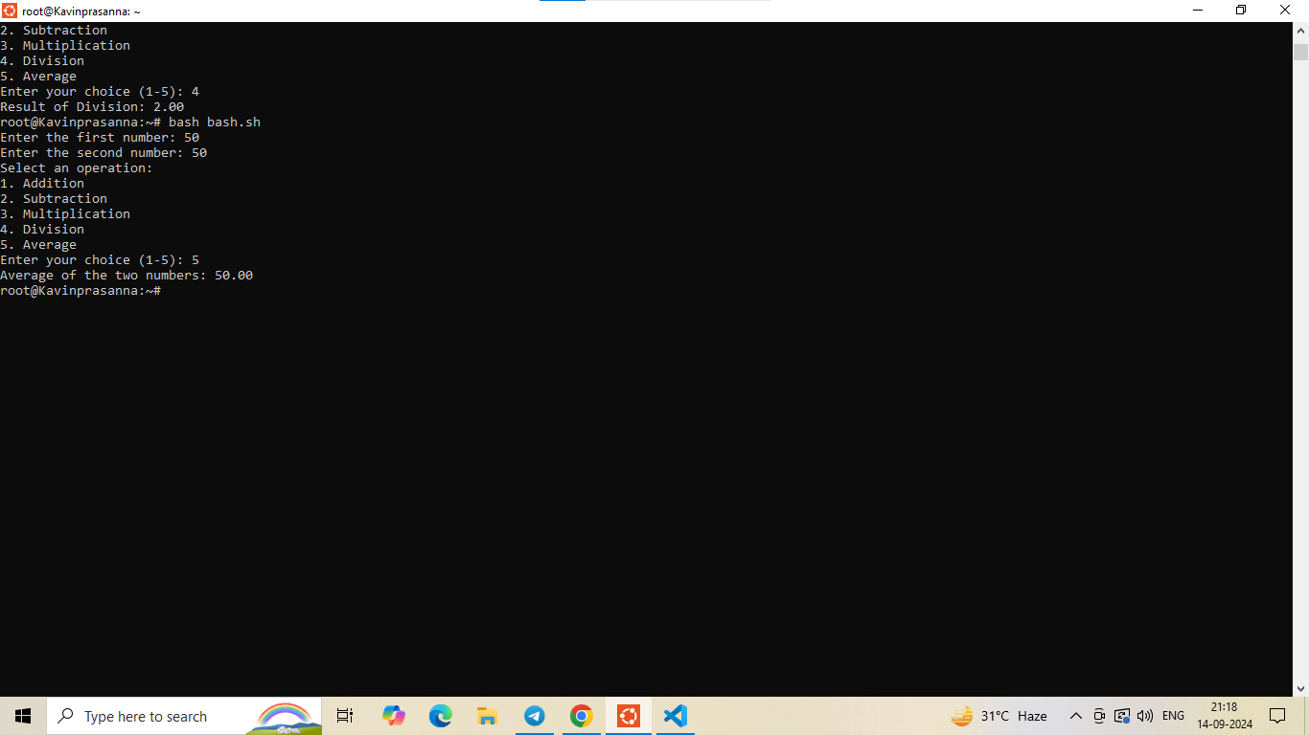

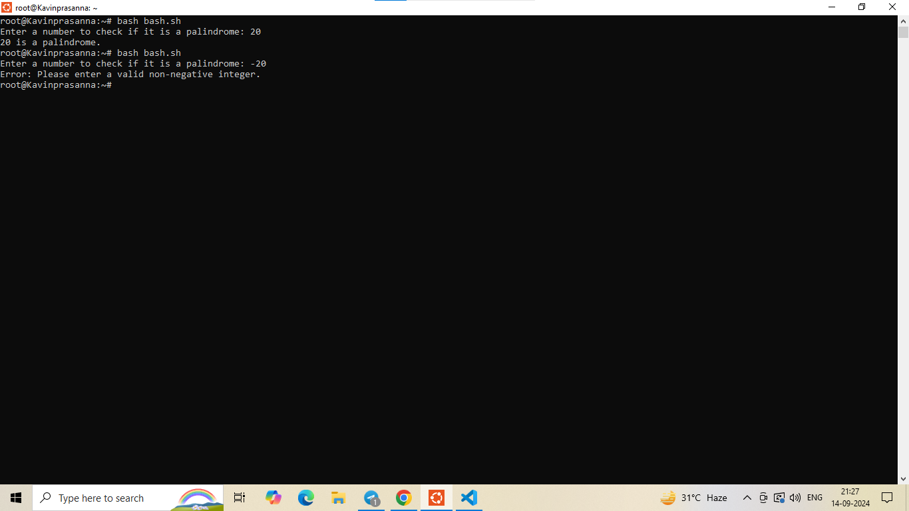

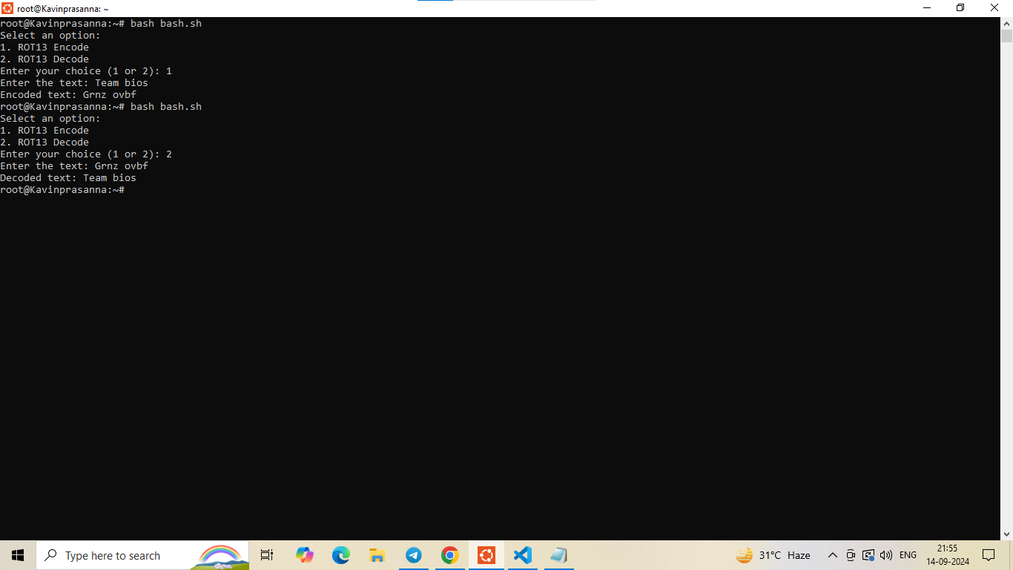

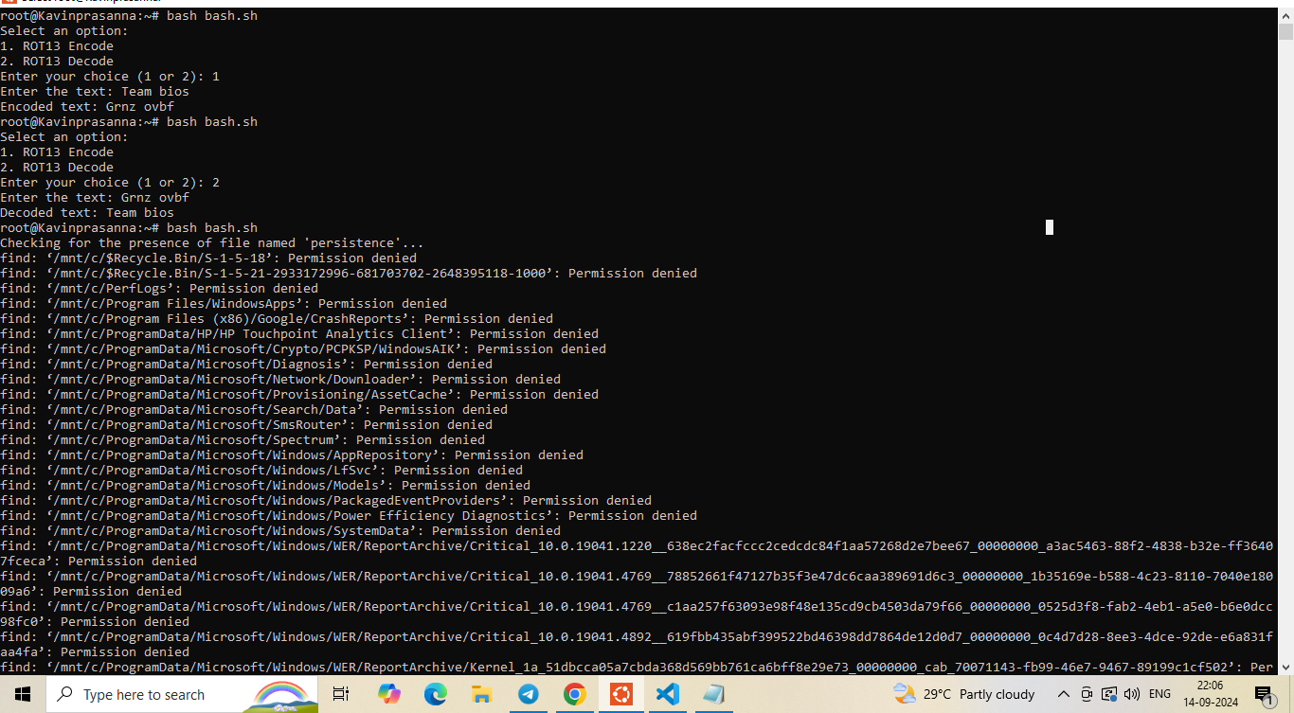

BASH SCRIPTING COMPLETED;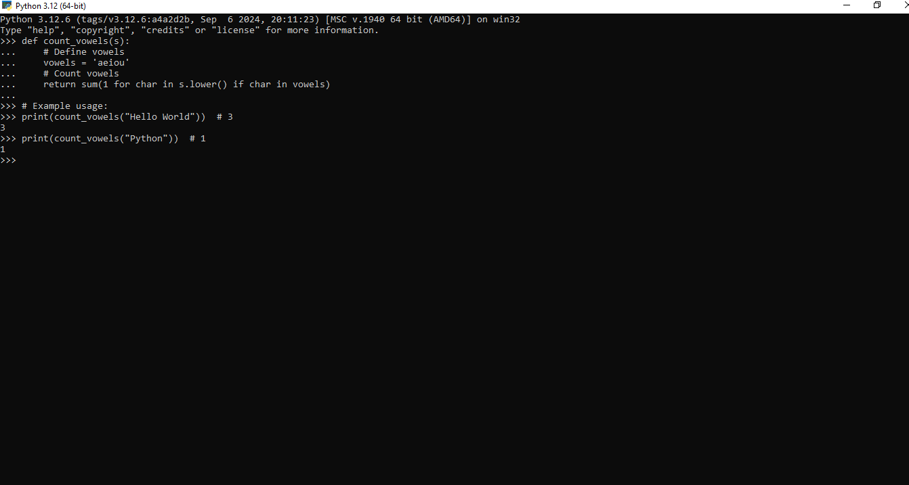

PYTHON;



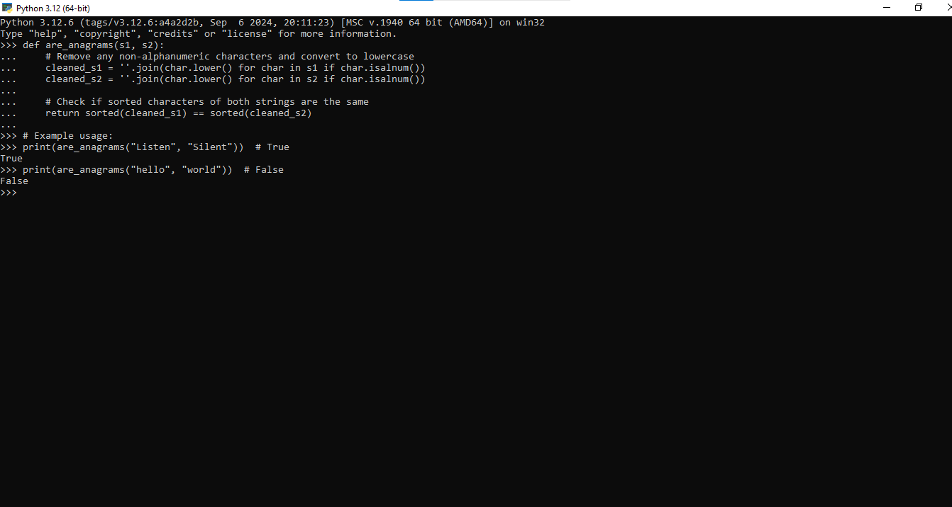

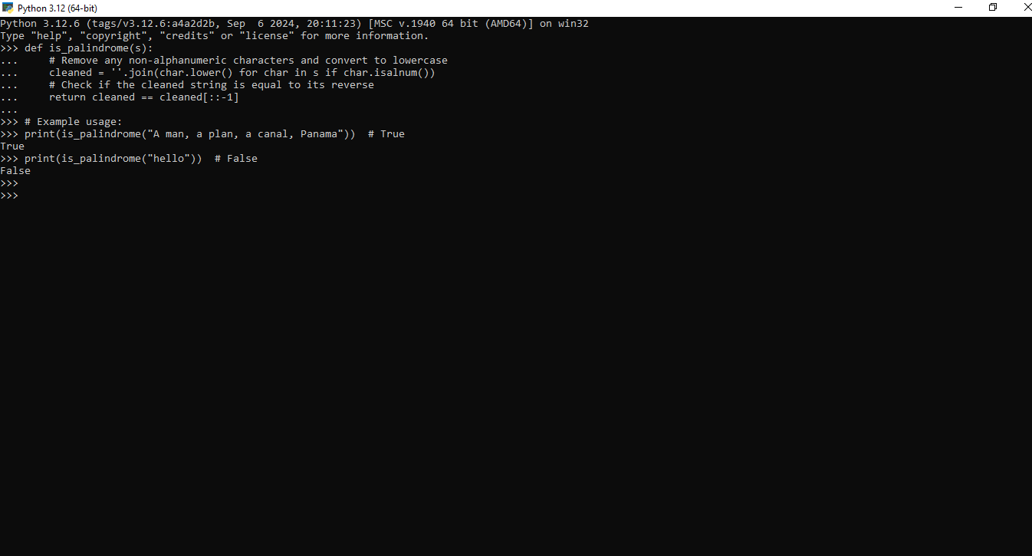

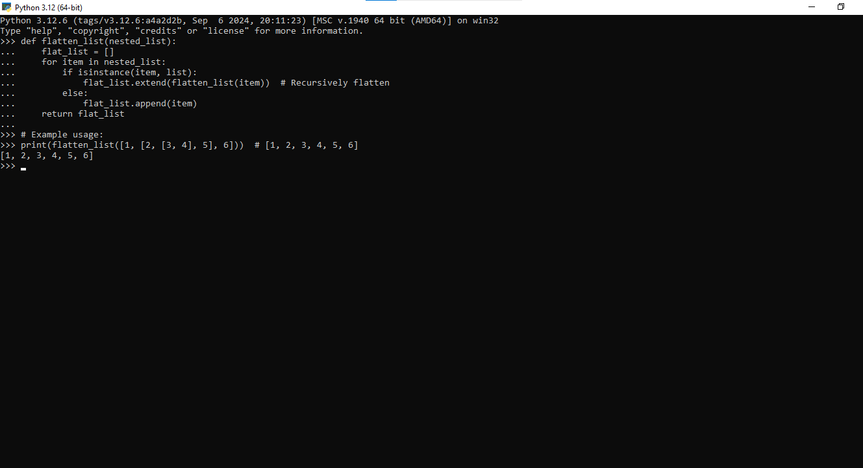

PYTHON PROGRAMMING LANGUAGES COMPLETED;